



# Batch: B-1 Roll No.: 16010422234 Name: Chandana Ramesh Galgali

# 

# Experiment No.: 01

**Aim:** Formulation of a problem definition for specific real world DMS system and Drawing ER/EER diagram for the same.



**Resources needed:** MS-office



# Theory:

**Entity relationship model** is a data model which represents the overall logical structure of a database and it is very useful in mapping the meanings and interactions of real world enterprises onto a conceptual schema.

The E-R model employs three basic notations:

**Entity sets:** An entity set is a set of entities of the same type that share the same properties .(an entity is a real world object)

**Relationship sets:** Relationship set is a set of relationships of the same type.(relationship is an association among several entities)

**Attributes:** Attributes are properties of the entity set used to describe it. Different types of attributes are composite, multivalued, derived and simple.

In **extended E R model** we have three additional concepts:

**Specialization:** The process of designating the subgroupings within an entity set is called specialization( finding specialized attributes)

e.g. in entity set person we have two types of entities like customer and employee. Both are persons but an employee has a specialized attribute salary and customer has rating.

**Generalization:** It is a top down design process in which multiple entity sets are synthesized into a higher level entity set on the basis of common features.

e.g. customer entity set and employee entity set both have common attributes like name, address, age which can be used as attributes of higher level entity set person. **Aggregation:** it is an abstraction through which relationships are treated as higher level entities.

The most important use of the E-R diagram is it represents some constraints like total and partial participation, one to one, many to many, many to one, one to many mapping etc.

# Symbols used in EER diagram:

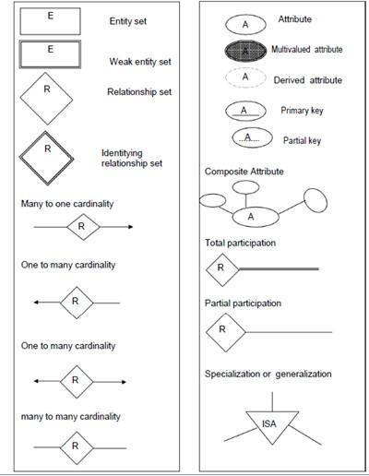



**Procedure:**

Identify the real world objects to start drawing the diagram

1. Entity – A real world object which can be converted into a table name.
2. Entity type – It defines the collection of similar types of entities.
3. Attributes – Properties of entity which describes the entity. Attributes are of different types
   1. Atomic Attributes
   2. Composite Attributes
   3. Single valued attributes
   4. Multivalued Attributes
   5. Derived Attributes
4. Relationship – When one entity refers to another entity type a relationship exists between the two entities.
5. Relationship types – A relationship type R among n entity types defines a set of associations among entities of other types.
6. Weak entity – the entity dependent on another entity is called a weak entity.
7. Specialization – this is the process of defining a set of subclasses of an entity type .It is derived from a super class depending upon different attributes.
8. Generalization – It is the process of abstraction in which we suppress the differences among several entity types grouping some entities and eliminating common features. We generalize them into a single super class.
   1. Disjoint – In this, entity can be a member of any one of the subclass
   2. Overlap – In this, an entity can be a member of more than one subclass.
   3. Total – All the entities are members of any one of the subclasses.
   4. Partial – Entity is not a member of any one subclass.
9. Union – the subclass represents a collection of objects.

This detailed problem statement gives the clarification about the database design.

This is a tool to find out missing functional dependencies to convert the schema to the appropriate normal form.

Formulate the problem definition to get the detailed description of the problem domain so that entities can be easily identified from the problem definition.

There are many components used in EER.

1. First find out the real world objects as entities.
2. Find out the attributes which will describe the object.
3. Find the relationships and the participation constraints.
4. Apply object oriented fundamentals and get the specialization and generalization objects.
5. Draw the diagram.



**Results: (Document printout/handwritten)**

1. Problem definition:

***AVIATION MANAGEMENT SYSTEM***

An aviation database management system is maintained where each passenger has a particular passenger ID, password and flight history. They can use the ID, password to log into the website and book their tickets.

The system is divided into 7 sections for systematic representation of data and for easy understanding by the passengers.

**Aviation Services** *contains* information such as Unique Service ID, Meal Services, Lounge Services, Airport Assistance and Medical Help.

Except a few **Aircrafts** all other aircrafts are *operated by* Airlines and contain information such as Aircraft ID, Aircraft Model, Engine Design and Manufacturer.

Aviation Services *manages* **Airports** and contains information such as Airport Name, Airport Location and Number of Runways.

Aviation services *comprises* **Airlines** and contains information such as Airline Name, Country of Origin and Fleet Size.

Aviation services *arrange* **Flights** and contain information such as Flight ID, Arrival Time, Departure Time, Arrival Location, Destination and Aircraft Used.

Flights are *used by* **Passengers** and contain information such as Passenger ID, Password, Name, Date of Birth, Age, Mobile Number, E-mail, Address, Bank Details and Flight History.

Passenger *purchases* **Tickets** which contain information such as Ticket ID, Flight Number, Seat Number, Seat Type, Price.

1. ER/EER diagram:

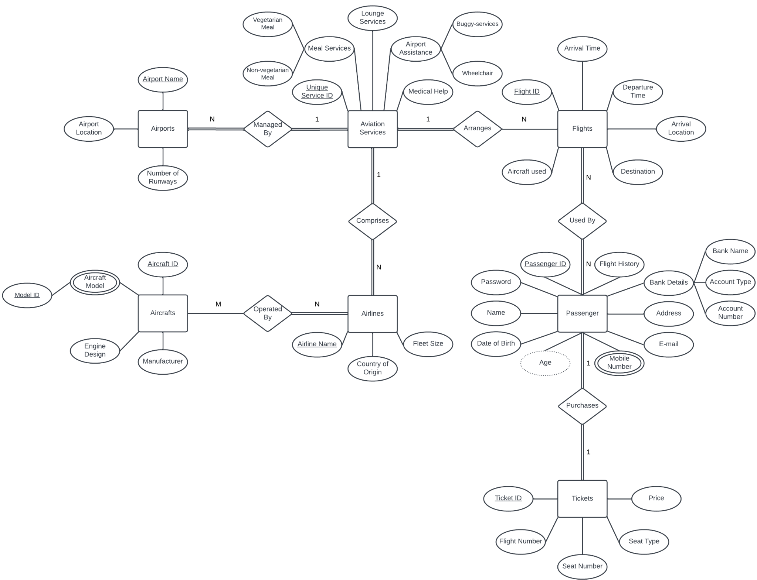

**Example:**

Problem Definition for COMPANY database system

The company is organized into DEPARTMENTs. Each department has a name, number and an employee who *manages* the department. We keep track of the start date of the departmentmanager.

Each department *controls* a number of PROJECTs*.* Each project has a name, number and islocated at a single location.

It stores each EMPLOYEE’s social security number, address, salary, gender, and birthdate. Each employee *works for* one department but may *work on* several projects. It keep track of the number of hours per week that an employee currently works on each project. We also keep track of the *direct supervisor* of each employee.

Each employee may *have* a number of DEPENDENTs. For each dependent, we keep track of their name, gender, birthdate, and relationship to the employee.



# Outcomes:

# **Apply data models to real world** scenarios**.**



**Questions:**

**Q1) Explain total and partial participation with examples.**

**Ans:** 1. Total Participation: Total participation refers to a situation where every entity in one entity set must participate in a relationship with entities in another entity set. In other words, every entity in the first set is required to be associated with at least one entity in the second set.

Example: Consider a database for a university. Let's say we have two entity sets: "Students" and "Courses." If we define a relationship set called "Enrollment" between these two entity sets, total

participation would mean that every student must be enrolled in at least one course. In this case, a

student cannot exist in the database without being enrolled in a course.

2. Partial Participation: Partial participation, on the other hand, allows entities in one entity set to participate in a relationship with entities in another entity set optionally. It means that some entities in the first set may not be associated with any entity in the second set.

Example: Continuing with the university database example, let's say we have another relationship set called "Faculty" between the "Courses" and "Professors" entity sets. If we define partial participation, it means that not every course needs to have a professor assigned to it. Some courses may have professors assigned, while others may not. In this case, the participation of professors in the "Faculty" relationship is optional.

To summarize, total participation requires every entity in one entity set to participate in a relationship, while partial participation allows for optional participation of entities in a relationship. These concepts help define the cardinality and constraints between entities in a database design.

**Q2) Differentiate between primary key and unique key.**

**Ans:** Primary Key:

1. A primary key is a column or a combination of columns that uniquely identifies each record in a table.
2. It must have a unique value for each record and cannot contain null values.
3. There can be only one primary key per table.
4. The primary key is used to establish relationships between tables (e.g., as a foreign key in related tables).
5. By default, most database systems automatically create an index on the primary key column(s) for faster data retrieval.

Unique Key:

1. A unique key is a column or a combination of columns that ensures the uniqueness of values within a table.
2. It allows for null values, but each non-null value must be unique.
3. A table can have multiple unique keys.
4. Unlike the primary key, a unique key is not used to establish relationships between tables.
5. Unique keys can be used to enforce business rules or constraints that require certain columns to have unique values.

In summary, the primary key uniquely identifies each record in a table, is mandatory, and is used for establishing relationships between tables. On the other hand, a unique key ensures the uniqueness of values within a table, allows null values, and is not directly used for establishing relationships.



**Conclusion:**

By formulating the problem definition and drawing the ER/EER diagram, the experiment aimed to provide a foundation for designing and implementing a database management system tailored to the specific requirements of an aviation management system.

**Reference books:**

1. Elmasri and Navathe, “Fundamentals of Database Systems”, 6th Edition, Pearson Education
2. Korth, Slberchatz,Sudarshan, :”Database System Concepts”, 6th Edition, McGrawHill
3. <http://vlabs.iitkgp.ernet.in/se/4/>